**CPE223 – Signals and Systems**



**Lab # 3**

|  |  |
| --- | --- |
| **Name** | Muhammad Aizaz Arshad. |
| **Registration Number** | 088. |
| **Class** | FA18-BCE-A. |
| **Instructor’s Name** | Sir Umair Shafique. |

**Assessment**

|  |  |  |  |
| --- | --- | --- | --- |
| **Performance** |  |  | **Total** |
| **Results** |  |  |
| **Lab Report** |  |
| **Viva** |  |

**OBJECTIVES:**

The objective of lab experiment is to display the periodic signals, casual signals, energy and power signals, even and odd signals, deterministic and stochastic signals using MATLAB. Show the results obtained after performing the composite operations on signals (time reversal, time scaling and time shifting) in MATLAB.

**REQUIRED EQUIPMENT:**

**Software:**

* **MATLAB**

**METHODOLOGY:**

Pre labs of this lab focused on even and odd decomposition of signals, and after adding even and odd parts. In lab tasks, focused was laid on periodicity and aperiodicity of the signals, and checking whether the signals were causal or non-causal. Then formulae and method for finding the energy and power of signals were introduced. Different functions were used to get desired output. The properties of time scaling were analyzed by compression and expansion of the signals in time domain of discrete and continuous time signals. Unit step sequence was decomposed into even and odd components and the limits of sinusoids and other given signals were taken according to each student’s roll number. According to them, energy signal has power equal to infinity and power signal has energy equal to zero. So signal can be energy or power or neither of them. Time delaying or forwarding was also introduced.

**LAB TASKS:**

T = 2*pi;

t = 0:0.0001: 3*(T);

x = cos(t) + sin(3*t);

plot(x)

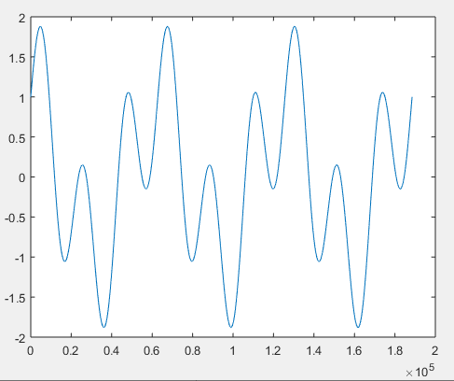

Task 2:

t = -5:0.1:5;

y = sin(t);

t1 = 0:0.1:5;

t2 = -5:0.1:0;

y1 = sin(t1);

y2 = sin(t2);

plot(t1,y1,'r')

hold on

plot(t2,y2, 'K--')

hold on

plot(t, 2*y, 'b')

legend('Causal', 'Anti-Causal', 'Non-Causal');

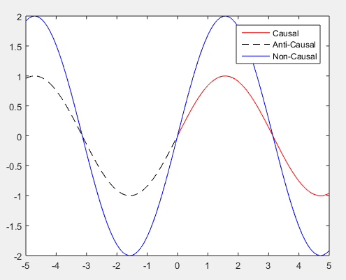

Task 3:

n = 0:0.1:6;

x = sin((pi*n)+2) + cos((2/3)*(pi*n)+1);

stem (n,x)

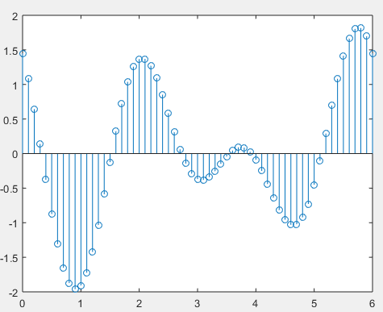

Task 4:

n = -20:20;

y = sin(pi.*n+2) + cos(2.*n/3+1);

stem (n,y)

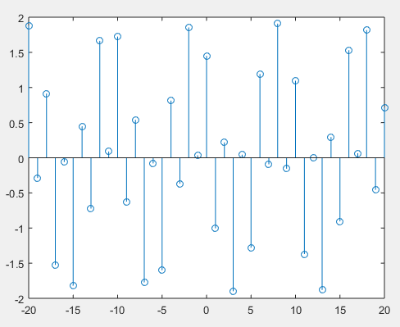

**CONCLUSION:**

In a nutshell, this lab mainly focused on the familiarization of students with functions and their using methodologies. Furthermore, in lab tasks of this lab allowed students to gain a proper knowledge of calculating energy and power of the signals and also verify the odd and even function using different commands, which is an important aspect in further studies of different type of signals and their waveforms